Environmental History of Latin America

Prof. Rick López
S2007: History 54
Monday and Wednesday, 8:30-9:50am
Office Hours: Monday, Tuesday, and Wednesday 2-4
Office: 23 Chapin, x5846

Environmental history has taken off in exciting new directions. Lament over the felling of the trees has given way to larger questions that connect environmental history with social, political, and economic issues. In this course we will focus on the unexpected links that exist between environmental problems (such as environmental degradation, desertification, soil “exhaustion”, species extinction, genetic simplification, biotic invasions, deforestation, pesticide contamination, and animal grazing) and human problems (such as colonial and imperial domination, declining subsistence, defense and violation of civil right, income inequality, scientific racism, regional underdevelopment, incomplete capitalist transformation, social marginalization, and political violence). Taking environmental history seriously forces us to revise our understanding of social changes, the rise and fall of civilizations, and contemporary problems of political instability. And putting current environmental debates into historical context enables us to grapple with the full complexity of the situation, a complexity too often invisible to environmental activists and to scientific researchers. Through a focus on environmental history, but also with careful attention to interdisciplinarity with the sciences and the humanities, the questions we will engage include: What models of environmental activism have worked in Latin America , and which have not? Why? What is typical about the Latin American context and what is unique? Can history guide us in our current efforts to develop a sustainable approach to the environment that helps the land and its fauna, but does so in a way that brings greater justice and self-determination to the people who live there, while at the same time balancing the interests of the state and of investors? How can what we learn about Latin America help us to think more productively about the causes and solutions to problems in other parts of the world?
While the structure and methodology of this course is historical,it takes an interdisciplinary approach, combining humanities, social sciences, policy studies, and the sciences. As such, the nature and approach of readings will vary greatly, and we will be joined in a few meetings by scientists.

Readings: Be an engaged reader. Don’t absorb the text, argue with it. See “Getting to Know a History Book” on the course website.

Attendance: Attendance is required.

Discussions: Whether class discussions are productive will depend entirely on what each of you brings to the table. The more carefully we all think about the readings and the issues before class, and the more intellectual risks you are willing to take, the more we can dive into the issues in discussion.
Newspapers: Peruse the news several times per week. You can use the New York Times (which offers free internet subscriptions on-line and has lots of free issues floating around campus) and other other newspapers and magazines in English, Spanish, or Portuguese, as well as from the AP and Reuters news lines. Each Monday week come prepared to discuss at least one article you have found, and to talk about what about it might be important.

Writing:
- We will be five papers during the course.
- All written work will be submitted electrocinally. When submitting written work be certain to write the correct assigned text in the subject box so that my email system can auto-sort your work into a special grading folder. MS Word attachments are preferred, but I will also accept WordPerfect and PDF files.
- Formatting: All written work must be typed in 12 point Times font, black ink, 1 inch margins on all sides, left-justificed, and double spaced. Your first page must include your name, the course, the name of the assignment, and the date in the upper left hand corner. Pages must be numbered. Points will be deducted for papers that are too long or too short, or that do not comply with the formatting instructions. Do not include a separate cover page. All sources must be footnoted. You must also footnote all ideas borrowed from others. Do not use in-text notations or endnotes. Use only footnotes. Note that books and articles are cited differently in footnotes than they are in bibliographies (see Style Guide). Proper formatting of your papers is an easy way to boost your grade. Improper formatting is an easy way to lower your grade.

Plagiarism: This is the ugly topic that we all hate to think about. Unfortunately, plagiarism does happen, and all faculty have been advised to take preventative, and, if necessary, punitive measures. When you take the words, work, or ideas of someone else and pass them off as your own you are committing plagiarism. Most students are honorable, and I do not expect that we will have any acts of plagiarism. However, if you decide to plagiarize your will receive an “F” for the entire course and I will turn the matter over to the dean with a recommendation for expulsion from Amherst College. If you have any doubt about how to acknowledge the work of others in your footnotes, consult the style guide.

I do not accept late work or allow you to make up a missed quiz except in cases of severe illness requiring extended hospitalization, a note from the dean, or a death in the family.

-Students with disabilities should speak with me at the beginning of the semester about any special arrangements they may require

How your semester grade will be calculated:
Class Attendance and Participation……………………………….…….…….…..35%
Attendance 10%
Participation 25%

Map quiz……………………………………………………………….……….………..5%

Papers…………………………………………………………………..….……..……60%
Five short papers @ 12% each

Required texts available at Jeffrey Amherst Bookstore:
Warren Dean, With Broadax and Firebrand: The Destruction of the Brazilian Atlantic Forest (Berkeley: University of California Press, 1995).
Stuart McCook, States of Nature: Science, Agriculture, and Environment in the Spanish Caribbean, 1760-1940 (Austin: University of Texas Press, 2002).

Required texts available at the History office in Chapin Hall
Part I of the coursepack
Part II of the coursepack
Coursepack supplement: Joel Simon, Endangered Mexico: An Environment on the Edge (San Francisco: Sierra Club, 1997), introduction, & chapters 2-4, 6-9.

Part I. What is Latin American environmental history?

Meeting 1: Monday, January 29
Intro: Who cares about the environment? What is Environmental History? And what does environmental history have to do with social conflict?
- (to be distributed in class) Larry Rohter, “South America Seeks to Fill the World’s Table,” New York Times, 12 Dec. 2004

Meeting 2: Wednesday, January 31
Historicizing the Environment: “Original Nature” versus Historical Nature
- (coursepack) William Cronon, selection from “The Trouble with Wilderness; or, Getting Back to the Wrong Nature,” from Uncommon ground: Rethinking the Human Place in Nature (NY: Norton, 1995), 69-87.
- (coursepack) Clinton R. Edwards, "The Human Impact on the Forest in Quintana Roo, Mexico," Journal of Forest History 30(3)(1986): 120-27.

Meeting 3: Monday, February 5
Environmental History as World History: Promises and Pitfalls
- Discuss Paper 1. Due by the end of Friday, February 9. Based on (coursepack) Greg Grandin, The Blood of Guatamala (Duke UP, 2000), 149-158.
- (coursepack) Alfred W. Crosby, "A Good Try at Organizing World History Environmentally," History and Theory 41(2)(2002): 218-24
- (coursepack) J. Donald Hughes, An Environmental History of the World: Humankind's Changing Role in the Community of Life (NY: Routledge, 2001), 42-48, 99-104, 113-119, 127-135, 217-224.

_______________________________________________________________________________________

Part II. Nature and Empire: Conquering People and Ordering Nature

Meeting 4: Wednesday, February 7
Assaulting the Brazilian Atlantic Forest: A Foundational Study
- (book) Warren Dean, With Broadax and Firebrand: The Destruction of the Brazilian Atlantic Forest (UC Press, 1995), 41-116.

Paper 1 due by end of Friday, February 9. Subject box must read H54 Paper 1. Your paper must come as an attachment. MS Word is preferred, but I will also accept WordPerfect and PDF files.

Meeting 5: Monday February 12
Spanish-Native “Conquest Landscapes”: A Foundational Study
- (coursepack) Elinore Melville, chapter 2 and 5, Plague of Sheep (Cambridge UP, 1994).

Meeting 6: Wednesday, February 14
Science, Nature, and Empire
- Discuss Paper 2. Due by the end of Friday, February 23. Based on the Journals of Hipólito Ruíz. In the coursepack.
- (coursepack) Londa Shiebinger, Plants and Empire: Colonial Bioprospecting in the Atlantic World (Cambridge, MA: Harvard 2004), 5-12, 23-25, 35-44, 51-58, 73-76, 82-89, and 194-225.

Meeting 7: Monday, February 19
The Aesthetics of Nature: Costumbrismo, Empire, Landscape, and Indigenous Realities
- Meet in Mead Art Museum
- (coursepack) Nancy Leys Stepan, Picturing Tropical Nature (Cornell UP, 2001), 11-56 and 240-245
_______________________________________________________________________________________

Part III. Global Economies, Informal Empires, and the Latin American Environment

Meeting 8: Wednesday, February 21
Science and the Brazilian Forest
- (book) Dean, With Broadax and Firebrand, 117-168.

Paper 2 due by end of Friday, February 23. Subject box must read H54 Paper 2.

Meeting 9: Monday, February 26
Science and Nature in the Caribbean
- Discuss Paper 3. Due by end of Friday, March 16.
- (book) Stuart McCook, States of Nature: Science, Agriculture, and Environment in the Spanish Caribbean, 1760-1940 (Austing: University of Texas Press, 2002), 1-76.

Meeting 10: Wednesday, February 28
Constructing Knowledge through Botanical Gardens
Meet at Smith’s Lyman Conservatory at 9am.
- (online) Read and explore http://www.smith.edu/garden/Conservatory/conservatory.html

Meeting 11: Monday, March 5
Agricultural Science and Export Economies in the Caribbean
- (book) McCook, States of Nature, 77-141.

Meeting 12: Wednesday, March 7
Dilemmas of Development and the Emergence of Domestic Environmentalism
- (book) Dean, With Broadax and Firebrand, 191-264.

Meeting 13: Monday, March 12
Local Knowledge versus Top-Town Projects
- (coursepack) James Scott, Seeing Like a State (Yale UP, 1998), 11-52, 262-306.

Meeting 14: Wednesday, March 14
Tropical Goods: Local Environment, Global Contexts, and International Capital
- (coursepack) Steve Marquardt, "'Green Havoc': Panama Disease, Environmental Change, and Labor Process in the Central American Banana Industry," American Historical Review 106(1)(2001): 49-80.

Paper 3 due by end of Friday, March 16. Subject box must read H54 Paper 3.

Spring Break: March 19-23

_______________________________________________________________________________________

Part IV. Dilemmas of Development and the Search for an Environmentalist Politics

Meeting 15: Monday, March 26
The Development Imperative in Brazil
- (book) Dean, With Broadax and Firebrand, 265-364.

Meeting 16: Wednesday, March 28
The Conservation Movement in Latin America, the Case of Mexico
- Discuss Paper 4. Due by end of Friday, April 20.
- (book) Lane Simonian, Defending the Land of the Jaguar: A History of Conservation in Mexico (Austin: University of Texas Press, 1995), 25-50, bottom 56-103, 107-113, 118-131, 132-165.

Meeting 17: Monday, April 2
Confronting Imperialism and Ecological Crisis in Central America
- (coursepack) Daniel Faber, Environment Under Fire: Imperialism and the Ecological Crisis in Central America (NY: Monthly Review Press, 1993), 3-9; 45-81; 93-115; 149-189; 234-235.

Meeting 18: Wednesday, April 4
Pesticides
Guest: Prof. Clotfelter (Biology)

Meeting 19: Monday, April 9
Grand Projects and their Aftermath: The World Bank, IMF, Modernization, and the State
- (coursepack) Brant H. Millikan, “Tropical Deforestation, Land Degradation, and Society: Lessons from Rondonia, Brazil," Latin American Perspectives 19 (1) (Winter 1992) (Special Issue: the Ecological Crisis of Latin America), 45-72.

Meeting 20: Wednesday, April 11
Dealing with the Depth of the Crisis: The Mexican Case, Part I
- (coursepack supplement) Simon, introduction and chapters 2, 3, and 4 from Joel Simon, Endangered Mexico: An Environment on the Edge (San Francisco: Sierra Club, 1997)

Meeting 21: Monday, April 16
Dealing with the Depth of the Crisis: The Mexican Case, Part I
- (coursepack supplement) Simon, chapters 6, 8, and 9, Endangered Mexico,

Meeting 22: Wednesday, April 18
Urban Air Pollution
Guest: Prof. McKinney (Chemistry)
- Divide the readings for Wednesday

Paper 4 due by end of Friday, April 20. Subject box must read H54 Paper 4. Your paper must come as an attachment. MS Word is preferred, but I will also accept WordPerfect and PDF files.

Meeting 23: Monday, April 23
Green Revolution to Genetic Modified Crops
- (coursepack) Peter Pringle, Food, Inc.: Mendel to Monsanto—The Promises and Perils of the Biotech Harvest (NY: Simon and Schuster), 38-56, 159-183.
- (coursepack) J. Timmons Roberts & Nikki Demetria Thanos, Trouble in Paradise: Globalization and Environmental Crises in Latin America (NY: Routledge, 2003), 68-76.

_______________________________________________________________________________________

Part V. History & Policy

Meeting 24: Wednesday, April 25
Indigenous Knowledge and Cooperative Strategies for Forest Management
- Discuss paper 5, due by end of Friday, May 18.
- Half the class will have read (email) Andrew Salvador Mathews, "Suppressing Fire and Memory: Environmental Degradation and Political Restoration in the Sierra Juárez of Oaxaca, 1887-2001," Environmental History 8, no. 1 (2003): 77-108.
- The other half of the class will have read (email) Dan Klooster, "Community Forestry and Tree Theft in Mexico: Resistance or Complicity and Conservation?" Development and Change [Great Britain] 31, no. 1 (2000): 281-305.

Meeting 25: Monday, April 30
Costa Rica: Model for Environmentalism?
- (email) Charles D. Brockett, and Robert R. Gottfried, “State Policies and the Preservation of Forest Cover: Lessons from Contrasting Public-Policy Regimes in Costa Rica,” Latin American Research Review 37(1)(2002): 7-40.
- Recommended: (email) Michele Zebich-Knoz, "Tropical Rainforest Policy in Brazil and Costa Rica: Has a Lesson been Learned?" Journal of the Third World Spectrum 1, no. 2 (1994): 91-104.

Meeting 26: Wednesday, May 2
Divergent Modes of Tourism and Regional Development
- (email) Edmund Andrews, “Junin Journal: Ecotourism is All Very Well, but $3 a Day Isn’t,” NYT 15 Nov. 2002.
- (coursepack) Roberts & Thanos, Trouble in Paradise, 83-86.
- (coursepack supplement) Simon, chapter 7, in Endangered Mexico, 180-204.
- (coursepack) Susan Place, “Ecotourism and the Political Ecology of ‘Sustainable Development’ in Costa Rica,” from Tropical Rainforests, 221-231.

Meeting 27: Monday, May 7
The Politics of Searching for Alternatives, Part I
- (coursepack) Fernando Funes, “The Organic Farming Movement in Cuba,” from Sustainable Agriculture and Resistance (Oakland, CA: Food First, 2002), 1-26.
- (coursepack) Selections from Green Guerillas, 121-177.

Meeting 28: Wednesday, May 9
The Politics of Searching for Alternatives, Part I
- (email) David Barkin, “A Strategy to Create New Beneficiaries from World Trade,” Agricultura, Sociedad y Desarrollo
- (online) Roger Hamilton, “Shoreline Showdown: How Ecuadoran Communities are Overcoming a Legacy of Environmental Conflict and Creating a Model for Coastal Management,” Unisa Latin American Report 15(2)(199): 61-67. http://www.iadb.org/idbamerica/archive/stories/1999/eng/e499e.htm
- (coursepack) Theodore Downing, et al, editors, Development or Destruction: The Conversion of Tropical Forest to Pasture in Latin America (San Francisco: Westview Press, 1992), 346-364.

Paper 5 due by end of Friday, May 18. Subject box must read H54 Paper 5.

January 29, Monday. Second semester classes begin.
March 17-25, Sat-Sun. Spring Recess.
May 11, Friday. Last day of second semester classes.
May 12-13, Sat-Sun. Reading/study period.
May 14-18, Mon-Fri. Second semester examination period.

Places to know for map quiz

Countries and Islands: | Cities: | Features, States, and Regions:
Mexico  Guatemala  El Salvador  Honduras  Nicaragua  Costa Rica  Panama  Cuba  Puerto Rico  Hispañola (Haiti & DR)  Colombia  Venezuela  Ecuador  Peru  Chile  Argentina  Uruguay  Paraguay  Bolivia  Brazil  Galapagos Islands (Ecuador)  Falkland Islands/Islas Malvinas | Mexico City (Mexico)  Mérida (Mexico)  Ciudad Juárez (Mexico)  Caracas (Venezuela)  Cancún (Mexico)  Antofagasta (Chile)  Santiago (Chile)  Buenos Aires (Argentina)  Asunción (Paraguay)  La Paz (Bolivia)  Rio de Janeiro (Brazil)  São Paulo (Brazil)  Brasilia (Brazil)  Salvador (Brazil) | Oaxaca (Mexico)  Yucatán (Mexico)  Chiapas (Mexico)  Central America  Quintana Roo (Mexico)  Chihuahua Desert (Mexico and US)  Sierra Madre Oriental (Mexico)  Andes Mountains  Pampas (the region in Argentina,)  Southern Cone  Rio Grande do Sul (Brazil)  Rio Grande/Rio Bravo (Mexico)  Amazonia (Brazil and beyond)  Altiplano  Caribbean  Tierra del Fuego  Patagonia  Rio de la Plata drainage basin  Iguaçu Falls  Rôndônia (Brazil)  Atlantic Forest (its original extent in Brazil)  Cerrado (Brazil)

All of these places and features can be found in good atlases and on the internet. You will find LANIC particularly useful. See “External Links” on Blackboard. Feel free to work within your groups to develop master maps and to study for the quiz.
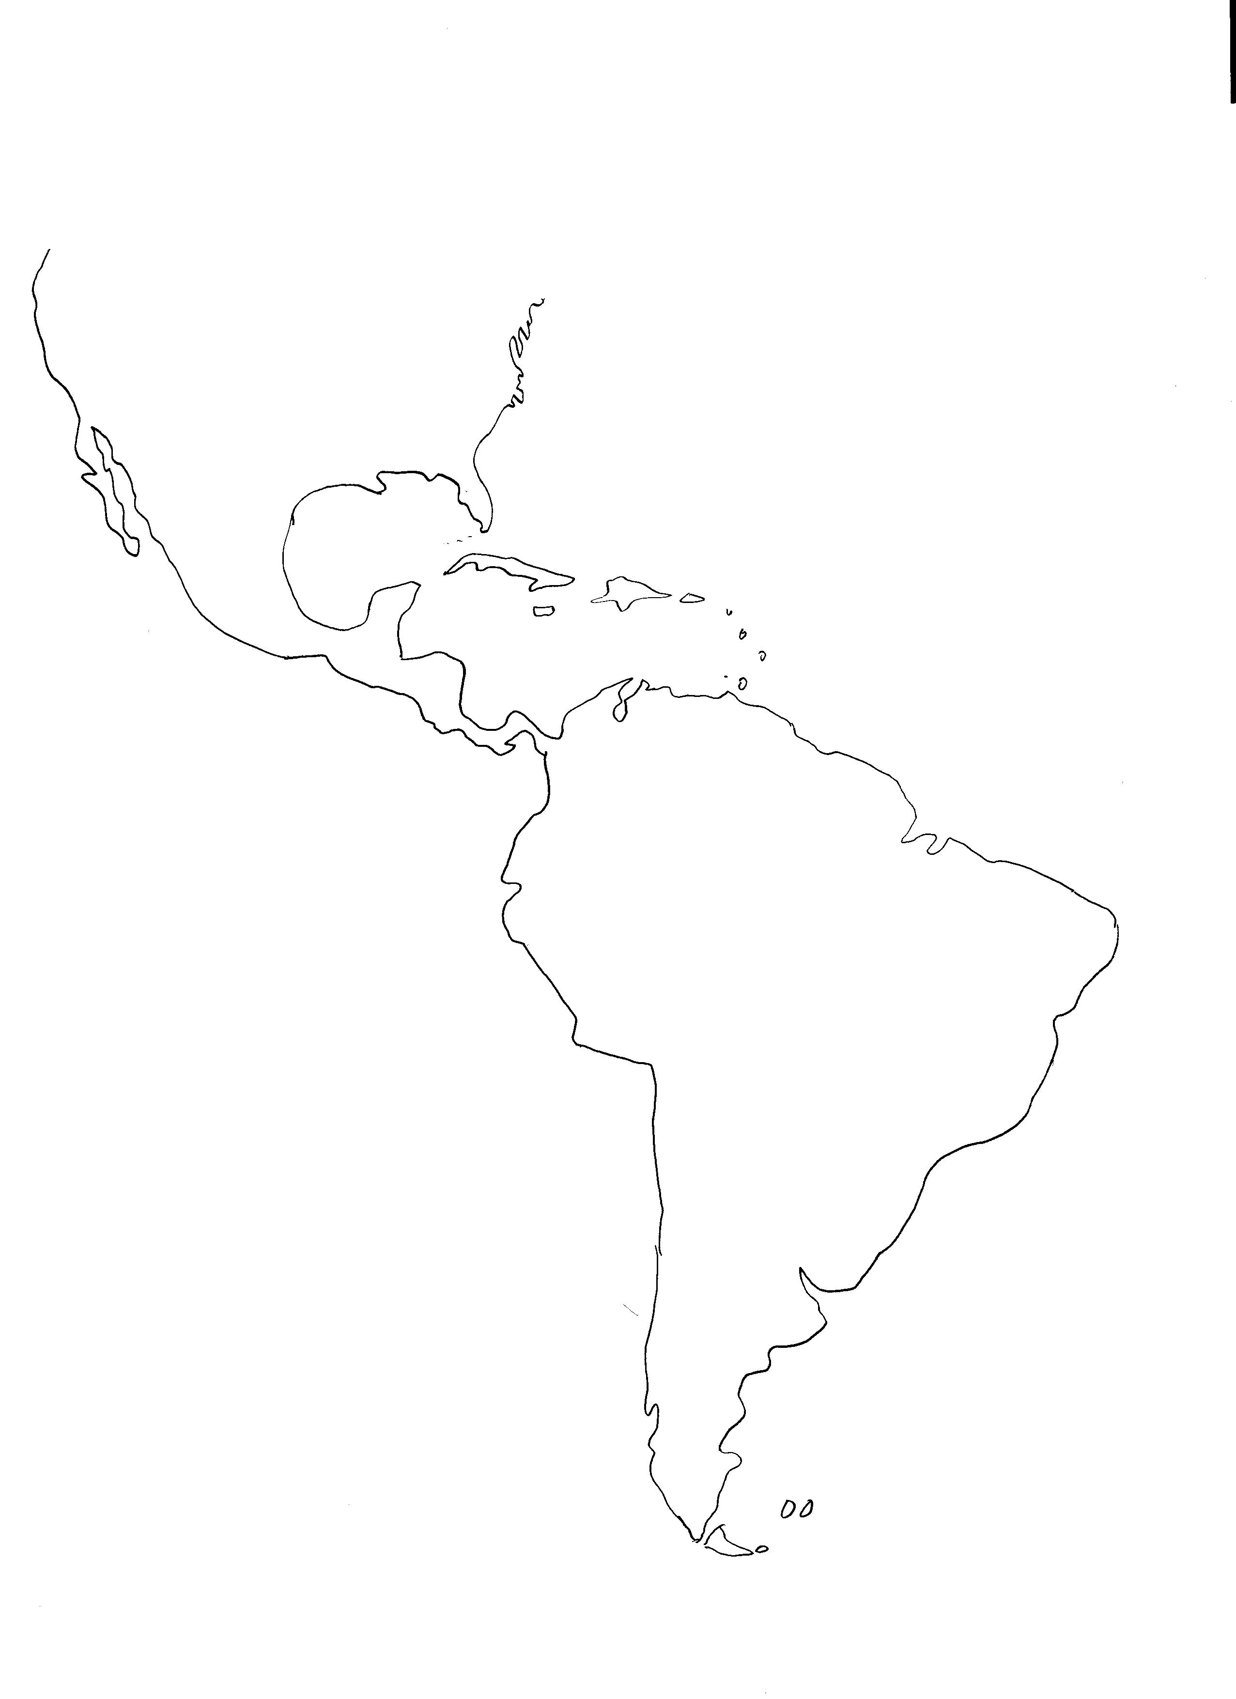
The map for the quiz will be identical to this one:

